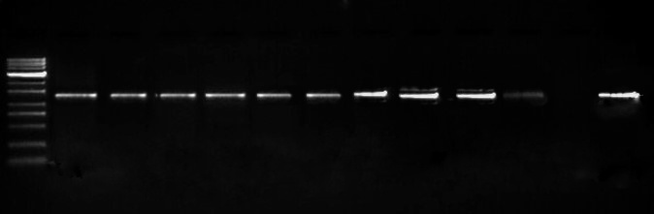
~ 1.2 kb

S1a. Rojas primers

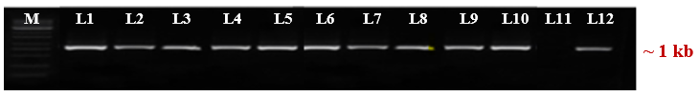
S1b. Coat protein gene

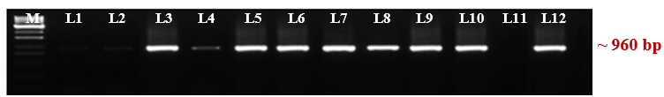
S1c. Movement protein gene

S1d. Rep protein gene

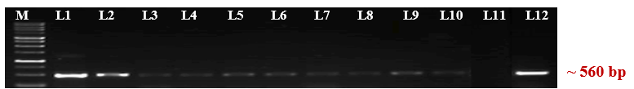

Fig. S1. Lane M -1 Kb ladder; L1, L2 -Vellimalaipatinam isolate; L3, L4 -Narasipuram isolate; L5, L6 -Sukkampatti isolate; L7, L8 -Kudumiyanmalai isolate; L9, L10- AC & RI TNAU isolate; L11- Negative control; L12- Positive control.

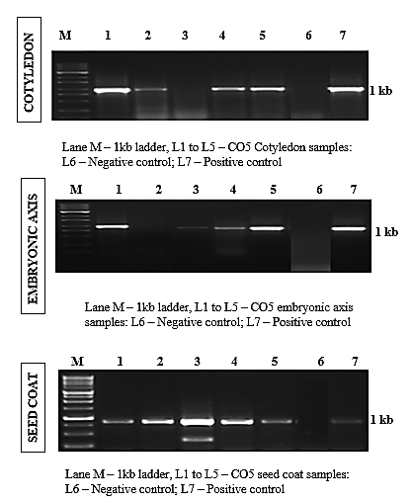
Fig. S2. Lane M -1 Kb ladder; L1 -5 – seed samples collected from grow out test plants; L6 - Negative control; L7 – Positive control.
S2b. Seed coat

S2a. Endosperm

Table S1. Documentation of yellow mosaic disease incidence in blackgram growing districts of Tamil Nadu

S.No | Location | District | GPS coordinates | Area in acre | Cultivar | Stage of the crop | Symptom | Percent disease incidence  (PDI)
1. | Vellimalaipattinam | Coimbatore | 10.9839118 N; 76.790815 E; | 2.50 | Local | Vegetative phase | Severe mosaic | 74.0%
2. | Narasipuram | Coimbatore | 10.9880 N; 76.7740 E; | 1.75 | Local | Vegetative and Flowering | Mosaic mottling | 78.0%
3 | Sukkampatti | Madurai | 10.16305769 N; 78. 41441231 E; | 2.75 | Local | Vegetative phase | Mild mosaic | 45.0%
4. | AC & RI Kudumiyanmalai | Pudukottai | 11.0053179 N; 76.91338815 E | 1.25 | CO5 | Vegetative phase | Severe mosaic | 65.0%
5. | AC & RI, TNAU | Coimbatore | 10.40395528 N;  78.67367709 E; | 1.25 | VBN10 | Vegetative phase | Severe mosaic | 72.0%

