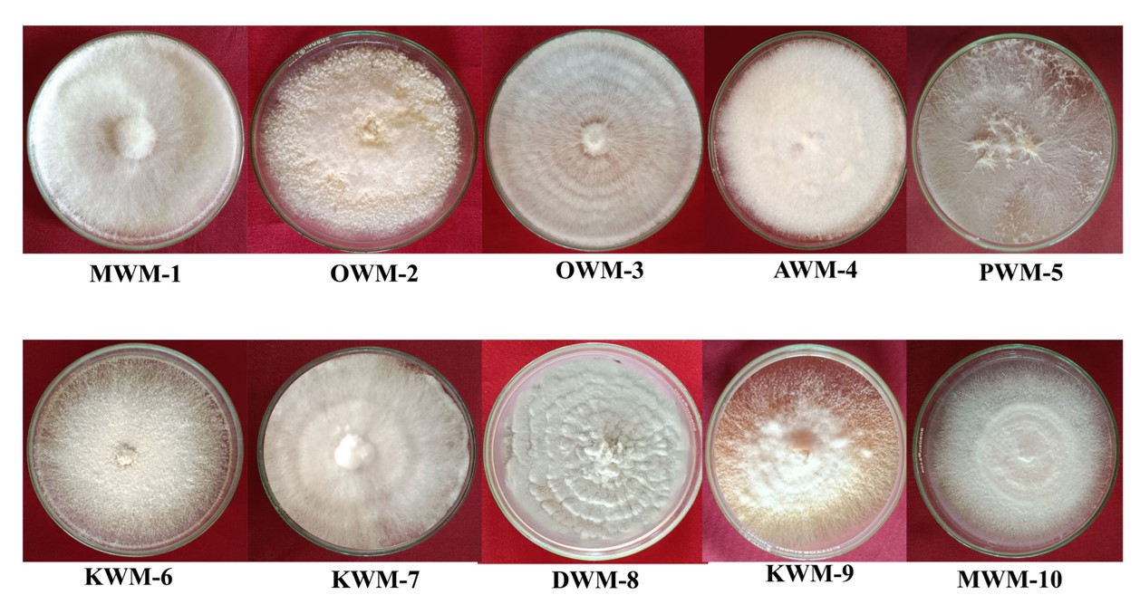
Supplementary Fig. 1. Morphological characteristics of various isolates of wild mushroom species based on the different mycelial growth and pattern.

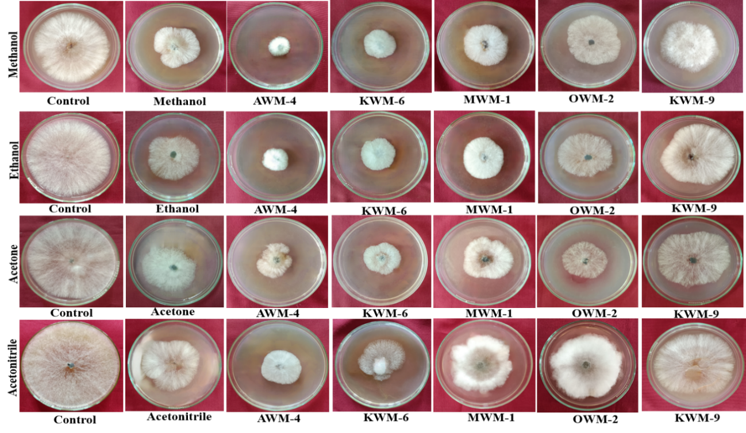
Supplementary Fig. 2. Antifungal activity of polar solvent of wild mushroom isolates AWM-4, KWM-6, MWM-1, OWM-2, KWM-9 against M. phaseolina using poisoned food technique.

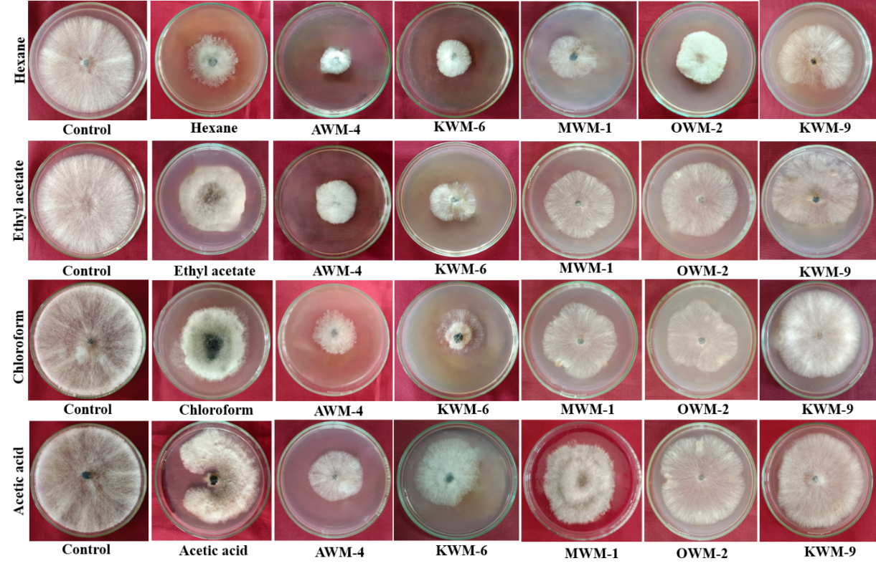
Supplementary Fig. 3. Antifungal activity of non-polar solvent of wild mushroom isolates AWM-4, KWM-6, MWM-1, OWM-2, KWM-9 against M. phaseolina using poisoned food assay.

